|  |  |
| --- | --- |
|  | Year 12 Specialist  TEST 4  27 July 2018  TIME: 50 minutes working  **NO Classpads NOR calculators** **allowed!**  50  Marks 7 Questions |

Name:_______________________________ Teacher: ____________________________

Q1 (2, 3, 3 & 2 = 10 marks)

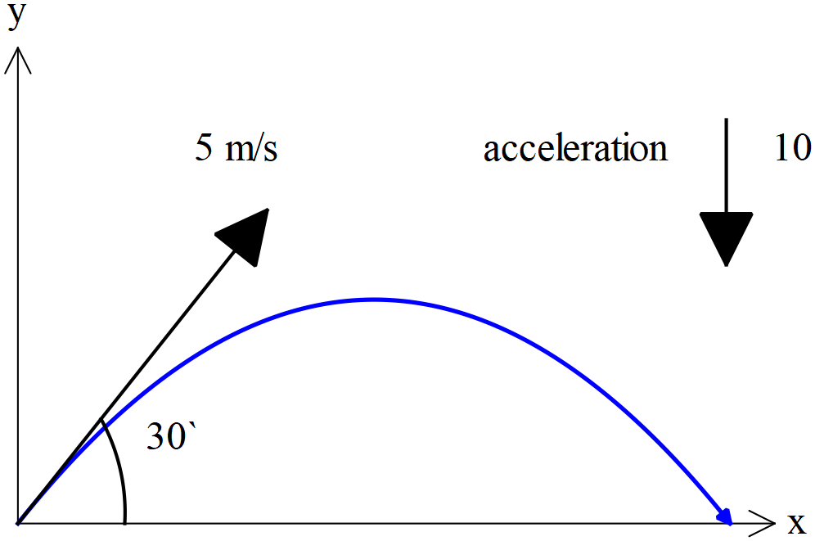

A particle is projected at the origin with an initial speed of  at  to the horizontal. The particle experiences a constant downward acceleration of .

Determine

1. the initial velocity of the particle in  form.
2. the position vector, ,  seconds after projection.
3. the cartesian equation of the path.
4. the range, that is the distance along the x axis when the particle lands.

Q2 (2, 3, 3 & 3 = 11 marks)

An object moves such that its position vector, metres, at time  seconds is given by



1. Determine the cartesian equation of the path of the object and the period of the motion.
2. Sketch the cartesian path giving the initial position and direction.

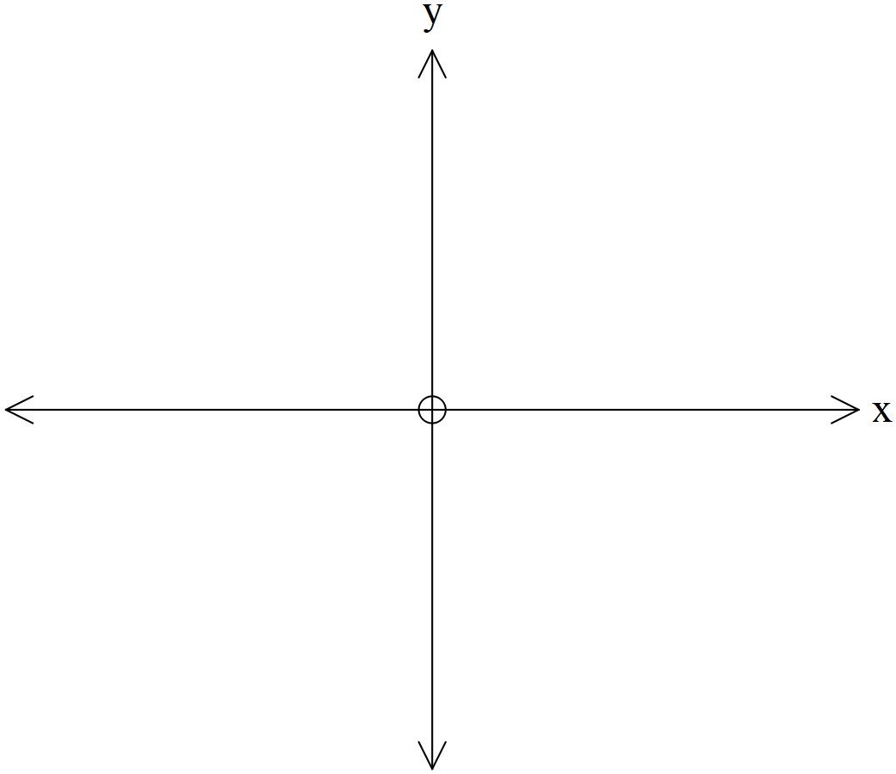

1. Show that the velocity is always perpendicular to the position vector.
2. Show that the acceleration is directly proportional to the position vector, stating the constant of

proportionality (i.e  where  is a constant)

Q3 (3 & 3 = 6 marks)

Consider the curve . In terms of  determine an expression for

1. 
2. 

Q4 (3 & 3 = 6 marks)

Show every step in evaluating the following integrals.

1.  with substitution 
2. 

Q5 (4 & 3 = 7 marks)

Consider the curve described parametrically by

 from  to 

If this curve is revolved around the x axis a three dimensional shape is formed.

1. Show that the volume of this three dimensional shape is 

(Hint- consider direction of integration)

1. Evaluate this integral to determine the exact volume.

Q6 (6 marks)

Consider the Ant-Man walking along a road AB towards point B at an incredible constant speed of .The height of the Ant-Man is 2 metres. Let point A be the closest point of the base of the Tall lamp from the road, i.e 5 metres and the height of the Tall lamp being 9 metres.

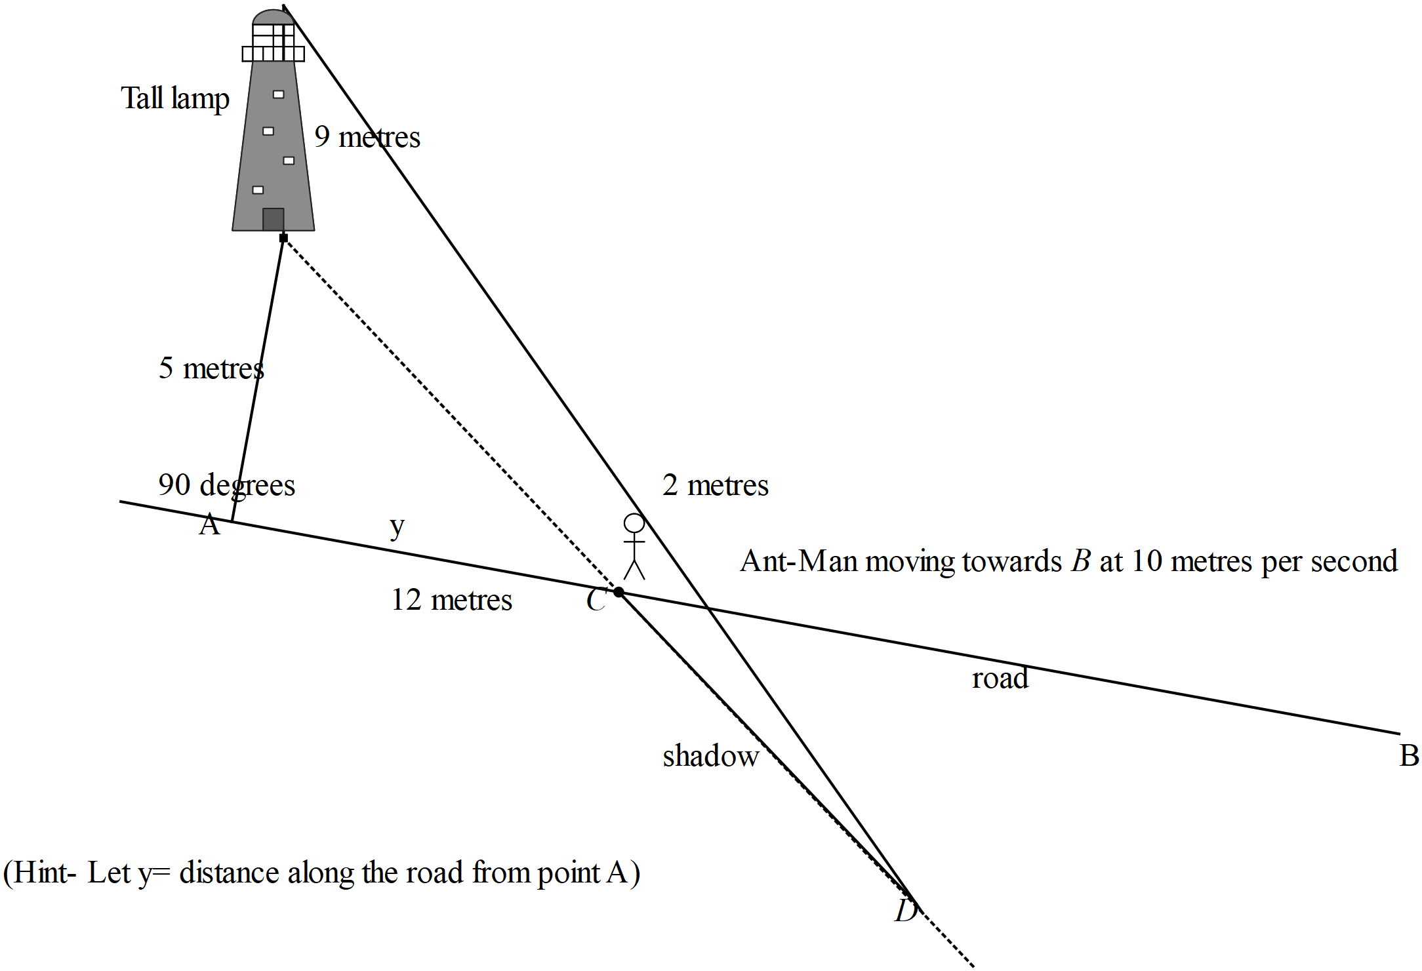

Determine at the point where the Ant-Man is **12 metres along the road** from point A, the time rate of change of the length of the shadow CD.

Q7 (4 marks)

By using an appropriate substitution **and** integration, show that

